A000-Roman-Rhyton-Sheep’s Head-Terra cotta-250 CE

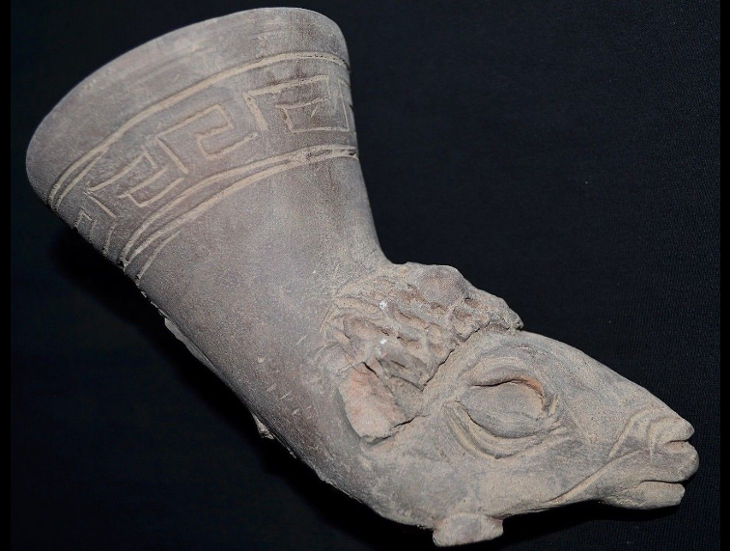 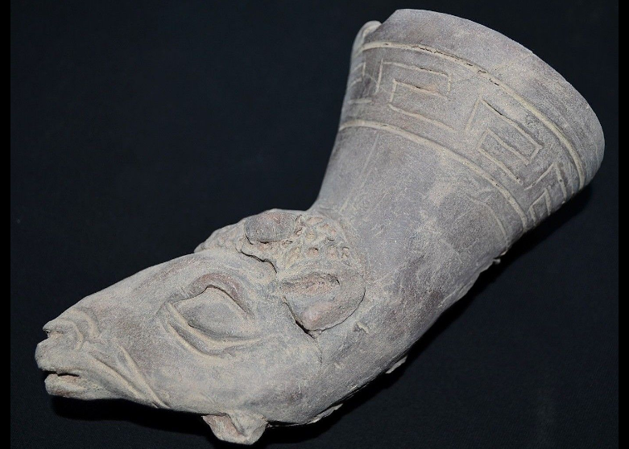

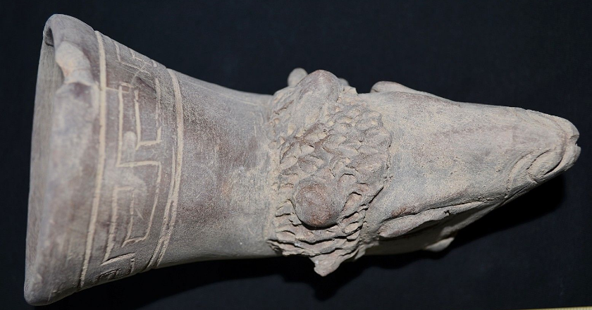

Figs. 1-3. Roman-Rhyton-Sheep’s Head-Terra cotta-250 CE

**Case no.: 4**

**Accession Number:**

**Formal Label:** Roman-Rhyton-Sheep’s Head-Terra cotta-250 CE

**Display Description:**

This sheep’s head rhyton may have been the emblematic drinking vessel of Roman Legion II, Avgvsta, stationed near Odessa on the Black Sea, ca 250 CE.

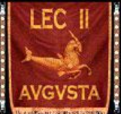

Fig. 4. Ram emblem of “2,” Roman Legion II, “Italica, Lower Moesia,” stationed near Odessa on the Black Sea after https://www.bing.com/th?id=OIP.ngIQDOqZaZPO73jpEA36XAHaF7&w=246&h=197&c=7&o=5&dpr=1.5&pid=1.7

**LC Classification: DG 89**

**Date or Time Horizon:** 250 CE

**Geographical Area:** Odessa, Ukraine, Odessa Oblast

**Map:**

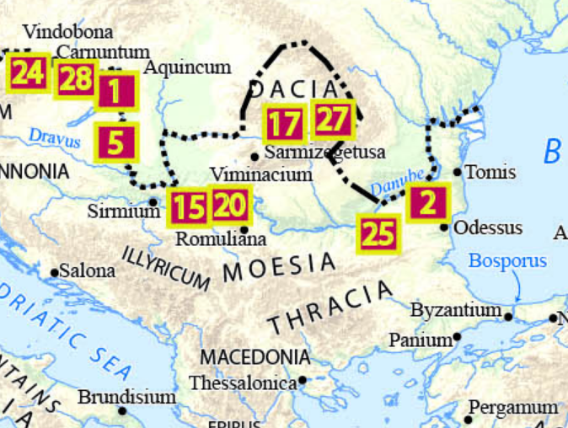

Fig. 5. Location of Legion II after https://upload.wikimedia.org/wikipedia/commons/6/69/Roman-legions-212-AD-Centrici-site-Keilo-Jack.jp

**GPS coordinates:**  46.4977,30.7248

**Cultural Affiliation:** Roman Legion II, “Italica, Lower Moesia,”

**Medium:** terra cotta

**Dimensions:**

**Weight:**

**Condition: original**

**Provenance:**

**Discussion:**

The Roman legion evolved from cohorts in the early Roman army but the development of subsequent legion organizations and emblems varied greatly over time. Typically, legions were comprised of around five thousand soldiers, and during the Republican Era, a legion was divided into three lines of ten maniples. In the Late Republic and much of the Imperial Period, a legion was divided into ten cohorts, each of six centuries. Legions also included a small *ala* or cavalry unit. By the third century CE, the Roman legion was a much leaner and better trained unit of about 1,000 men.

**References:**

Parker, Henry Michael Denne. 1993. *The Roman Legions*. New York, N.Y.: Barnes & Noble.